# Project Report

Unveiling Market Insights: Analysing Spending Behaviour and Identifying Opportunities for Growth.

1.Introduction

Understanding customer spending behavior is essential for businesses to grow and succeed. By analyzing customer spending data, businesses can identify trends, patterns, and opportunities. This information can be used to develop new products and services, improve marketing campaigns, and target customers more effectively.

1.1 Overview

*The report will use a variety of data sources, including customer surveys, transaction data, and market research data, to analyze customer spending trends, patterns, and factors that influence spending decisions.

*The report will also identify emerging trends, unmet needs, and competitive opportunities in the market.

*A retailer could use the report to identify the products and services that are most popular with their customers, and to develop targeted marketing campaigns for those products and services.

1.2 Cost and Time

The cost of conducting market research and developing the report can be significant, especially for small businesses.

Conducting market research and developing the report can be a time-consuming process. This may be a challenge for businesses that are short on resources or that need to make decisions quickly.

2.PROBLEM DEFINITION THINKING

EMPATHY MAP

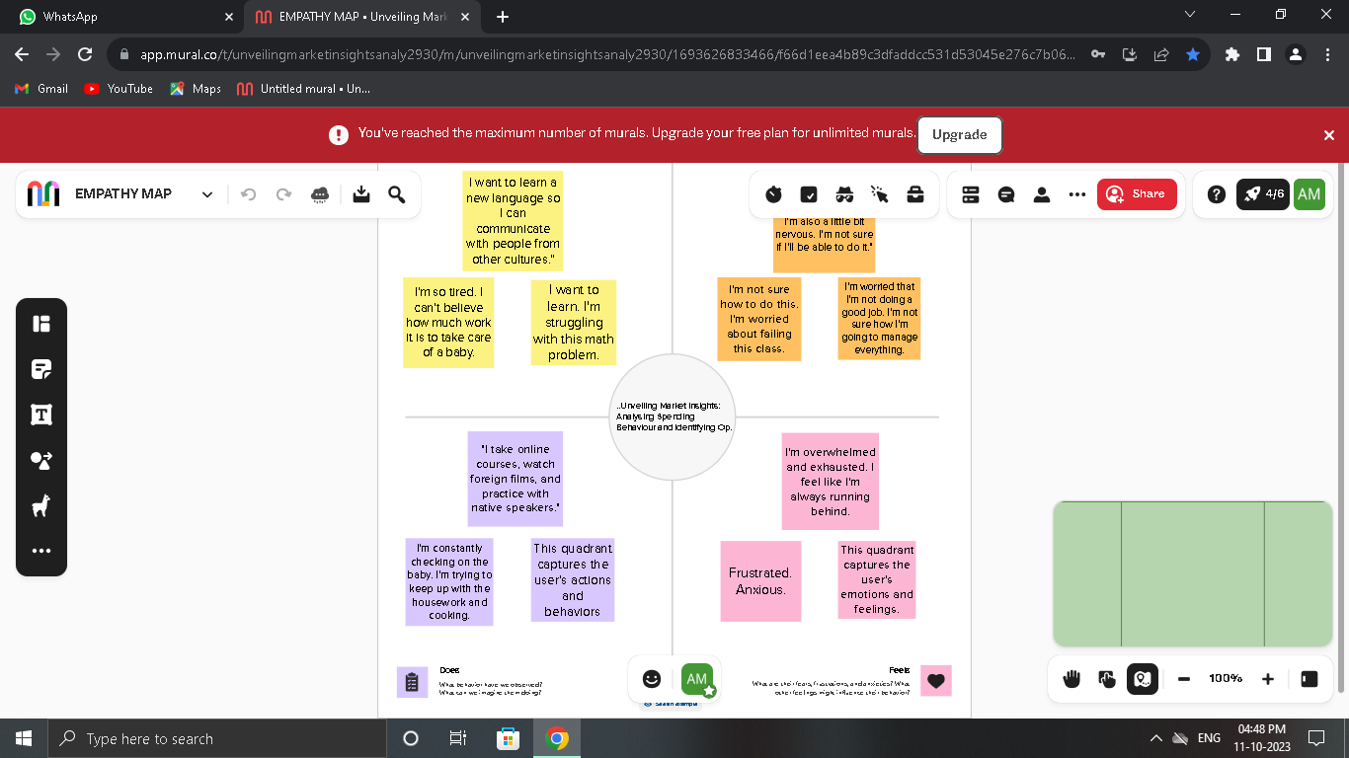

BRAINSTORMING

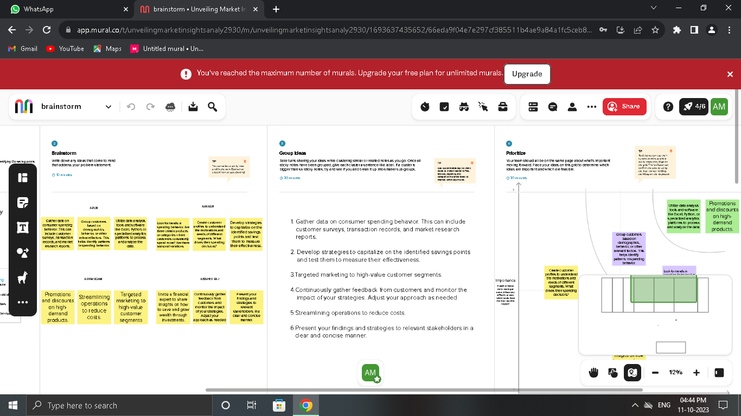

3.RESULT

DASHBOARD AND STORY

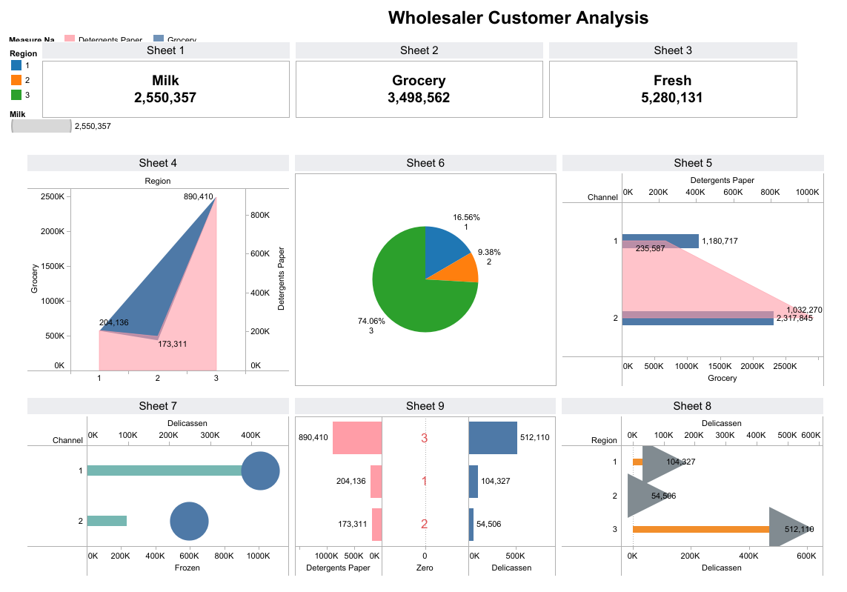

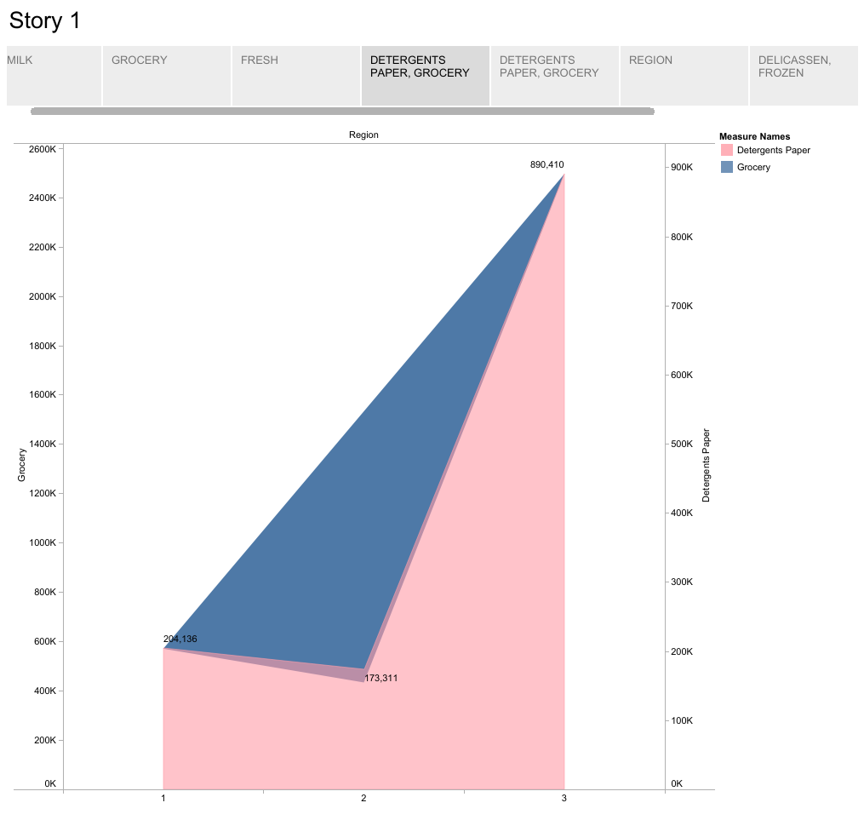

4.APPLICATIONS

* A retailer could use the report to identify the products and services that are most popular with their customers, and to develop targeted marketing campaigns for those products and services. For example, if the report shows that a majority of the retailer's customers are young professionals, the retailer could develop marketing campaigns that target this specific demographic.

* A manufacturer could use the report to identify new product opportunities or to improve existing products based on customer feedback. For example, if the report shows that many customers are unhappy with the durability of a particular product, the manufacturer could develop a new version of the product that is more durable.

5.CONCLUSION

The project report "Unveiling Market Insights: Analysis Spending Behavior and Identifying Opportunities for Growth" has provided a number of valuable insights into customer spending behavior and market trends. The report has also identified a number of opportunities for businesses to grow and succeed.

6.FUTURE SCOPE

The report could include additional data sources, such as social media data and customer surveys. This would allow for a more comprehensive analysis of customer spending behavior and market trends.

Include case studies: The report could include case studies of businesses that have successfully used the report's findings to achieve their growth goals. This would provide businesses with concrete examples of how the report can be used to achieve success.

THANK YOU